Electrical Connector Servicing Tools

# As it were….

I have found myself in need of better tooling and reference material for electrical connector servicing. The following should serve as a reference to the tooling Tri-Met has/has previously had and should have. Some tools are cost effective for the floor technician and some are not.

I have used digikey.com as a preferred supplier but I have thrown on some amazon.com links. Individuals should be able to google most tool part numbers and find a reputable supplier reliably.

This document **should not** be treated as a direct shopping list. I have included a lot of alternates and speculative tools in an effort to encompass the topic as best as I could.

This document is broken down into the following sections

1. Crimp tools
2. Connector Pin tools
   1. Cannon plugs
   2. Fine tip pin tools
   3. Harting brand connector tools
   4. Molex
   5. TE Connectivity
   6. Plastic round connector tools
3. Pin install pliers
4. Generic pin tools
5. Wire stripping tools
6. Cannon plug pliers
7. Terminal release tools

### Description for crimping tools

ITT/Cannon, Veam model– this brand is a circular multi-conductor connector used extensively in T2 and 3 trains here at Tri-Met. This Veam connector line conforms to MIL-DTL-5015 specification, so it has a structured set of tooling standards.

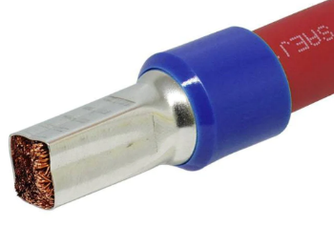Ferrules are a conductor sleeve that is crimped in certain ways to accommodate certain connections. I have found this to be very industrial/automation centric.

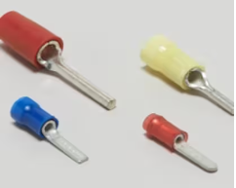TE connectivity/AMP generic PIDG! Pre-insulated diamond grip spade crimper is used extensively in T1 and on some places elsewhere in the fleet

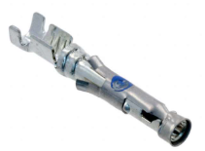TE Connectivity/AMP CPC connectors – These connectors are used extensively in the T1-3 fleet and in some places elsewhere such as the TWC connections for the T4-5.

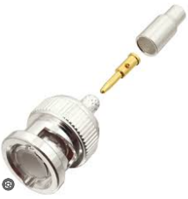Amphenol – BNC connectors. We use coax cables around the fleet for CCTV, radio and Wi-Fi antenna connections.

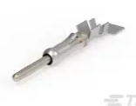Generic crimpers – a lot of terminals we use can be sufficiently crimped with a good quality set of generic W crimpers. There are several different sizes of crimps to be made in this area so it may not be surprising that there are 2-3 sets of crimpers we need to accomplish the range of crimps we have to do.

### Crimping tools

1. DMC AF8 plus turrets - **$500 - $1125**
   1. This one takes turrets and one generic pin stopper
   2. 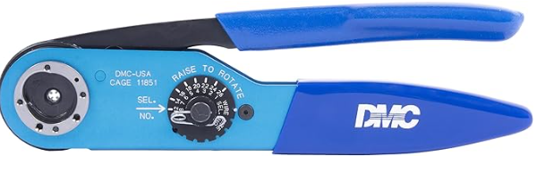
   3. https://dmctools.com/af8
   4. https://www.digikey.com/en/products/detail/amphenol-sine-systems-corp/AF8/7692154
2. DMC AFM 8-smaller one - **$450-$1125**
   1. This one needs specific pin stoppers
   2. 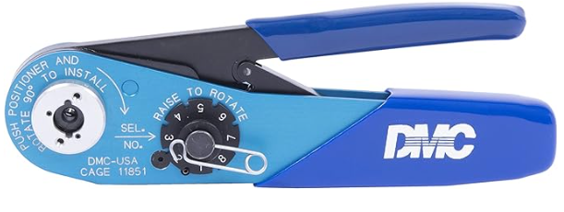
   3. https://dmctools.com/afm8
   4. https://www.digikey.com/en/products/detail/amphenol-sine-systems-corp/AFM8/7692156
3. Good quality generic W shape crimping tool medium - **$50-200** Tri-Met has a few sets of varying quality
   1. 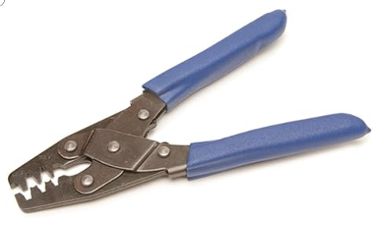
   2. https://shop.snapon.com/product/Crimpers-(Blue-Point)/Crimping-Tool-(Blue-Point)/PWC47
   3. https://www.mactools.com/products/18600 - This is one that Tri-Met has purchased before
   4. https://www.painlessperformance.com/wc/70900 -- $32.00
4. Good quality generic small gauge W crimping tool **$40 – 120**
   1. https://www.engineertools-jp.com/pa092021
   2. 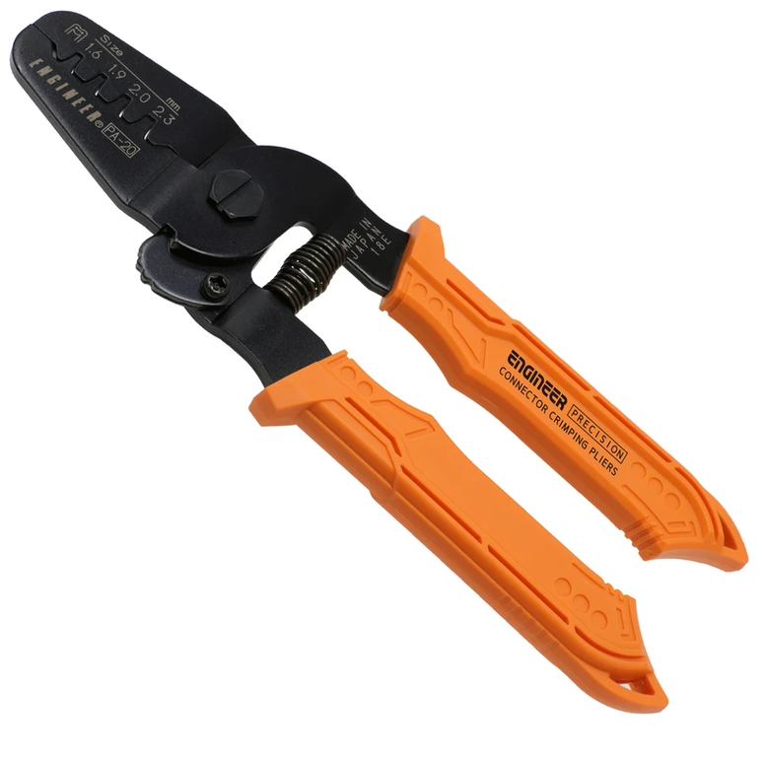
5. Knipex ferrule crimper 97 53 04 **$265.00** Tri-Met has a set
6. https://www.digikey.com/en/products/detail/knipex-tools-lp/97%252053%252004/10451678
   * 1. 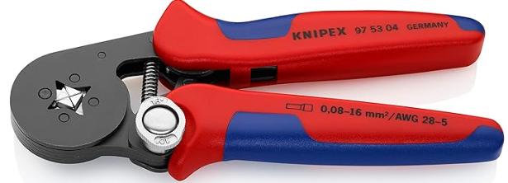
7. Rj45 crimper – Klein vdv226-011 **$50.00** Tri-Met has a set
8. https:\www.digikey.com\en\products\detail\klein-tools,-inc.\VDV226-011-SEN\6804514
   1. 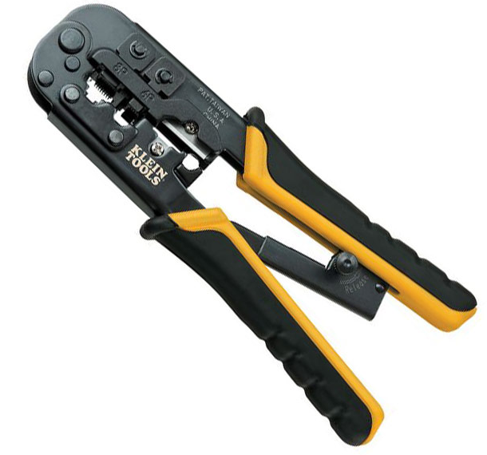
9. Coax crimpers. List link. https://www.amphenolrf.com/tools/crimp-tools.html
   1. Normal coax size = 0.255, FME APC antenna cable = 0.213
      1. https://www.amphenolrf.com/ctl-17.html **$158.43** Tri-Met has or had a pair.
      2. https://www.digikey.com/en/products/detail/amphenol-rf/CTL-17/5035593
      3. 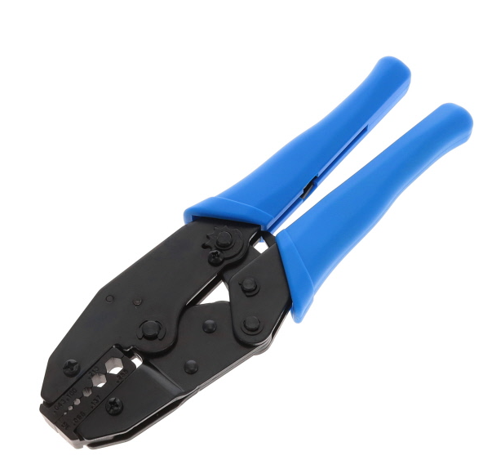
   2. Smaller coax size, see radio and APC Wi-Fi coax size. Unable to purchase this in a frame.
      1. https://www.amphenolrf.com/47-20025.html **$42.50**
      2. 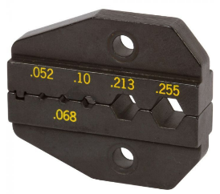https://www.digikey.com/en/products/detail/amphenol-rf/47-20025/101050
10. Amp – 59824-1 PIDG terminal crimper **$496.24** available in parts dept.
    1. https://www.digikey.com/en/products/detail/te-application-tooling/59824-1/297746
    2. 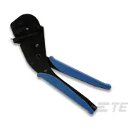
11. Amp/TE connectivity 47386 PIDG (Pre-Insulated Diamond Grip)crimper 16-26AWG **$953.19** Tri-Met has a set.
    1. This works on most generic PIDG terminals but maybe only the red class
    2. https://www.digikey.com/en/products/detail/te-application-tooling/47386/298065
    3. 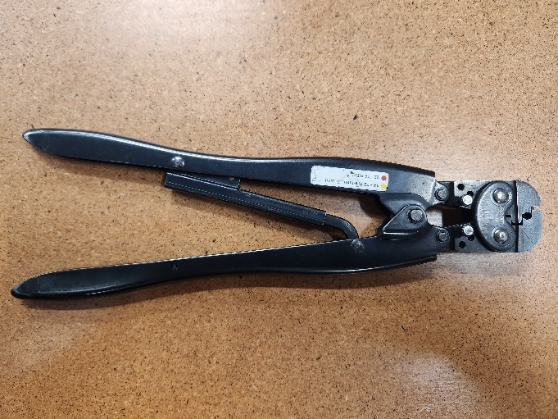
12. AMP/TE Connectivity 59239-4 12-10AWG yellow terminal **$1386.09** panto rebuild has a set.
    1. https://www.digikey.com/en/products/detail/te-application-tooling/59239-4/297754
    2. 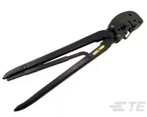
13. AMP/TE Connectivity 47387 20-14 AWG **$919.91** Tri-Met has a set
    1. https://www.digikey.com/en/products/detail/te-application-tooling/47387/333436
    2. 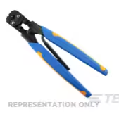
14. Snap on 29ACF **$76.25**
    1. While this model has many contemporary’s but I happen to like the forging and finish on the Snap On model
    2. 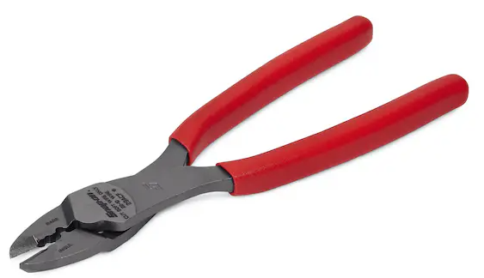
15. TE connectivity crimper body 354940-1 $132
    1. https://www.digikey.com/en/products/detail/te-application-tooling/354940-1
       1. This is a crimper with no jaws. The jaws are application specific
    2. 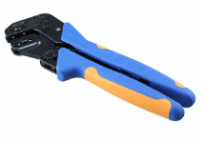
16. Harting 09990000620 $524.48 Tri-Met has one
    1. https://www.digikey.com/en/products/detail/harting/09990000620/3181527
    2. 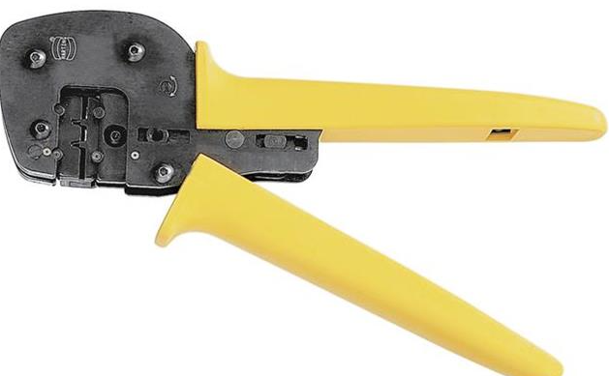
17. Knipex 97 53 08 $256.88 panto rebuild has one
    1. https://www.digikey.com/en/products/detail/knipex-tools-lp/97%252053%252008/16013894
    2. 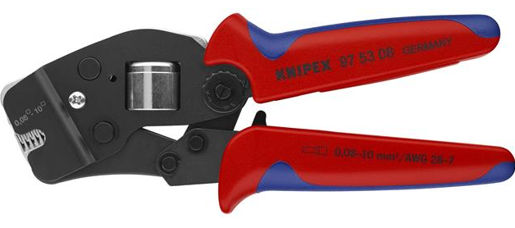
18. Knipex 97 68 145 A $40.00 panto rebuild has one
    1. Source from amazon maybe
    2. 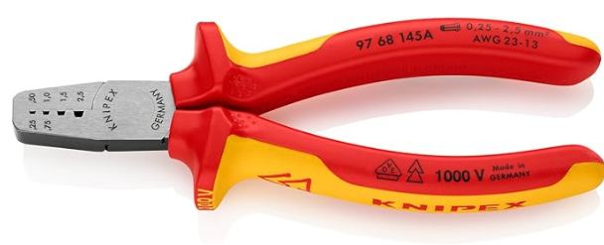

### Description for pin insertion/extraction tools

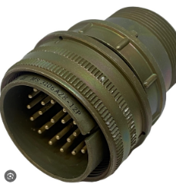Mils spec- Cannon brand Veam model plugs.

These plugs conform to MIL-DTL-5015 and will have a fairly preset standard of pin sizes, tools and methods

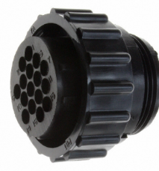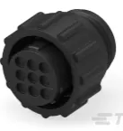TE connectivity/AMP CPC-

These plug family is used extensively in our trains, such as TWC, Sutrac hvac, T2-3 carbody …etc

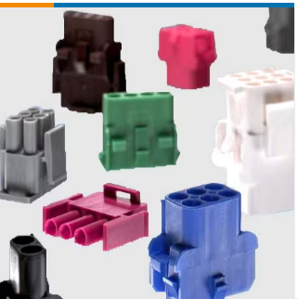TE connectivity Mate-N-Lok

While similar to Molex I have seen these located all over

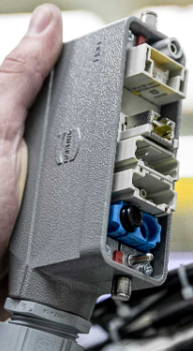

Harting HAN Modular-

I believe that this is the connector standard that is replacing the cannon plugs from here on out. This is a mainstay of automation systems.

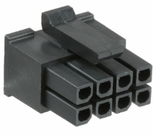Molex – various-

These plugs are usually found in T1-3 CCTV and in hobbyist areas but there is occasionally a reason to repair or replace a plug.

# Pin install/removal tools

### Mils Spec/Cannon/ITT Veam connectors

1. Veam A43240 $322.45
   1. https://www.mouser.com/ProductDetail/ITT-Cannon/A43240
   2. 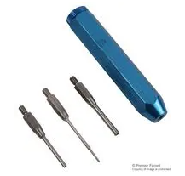
2. Veam 11-7576-37
   1. Unknown purchase source

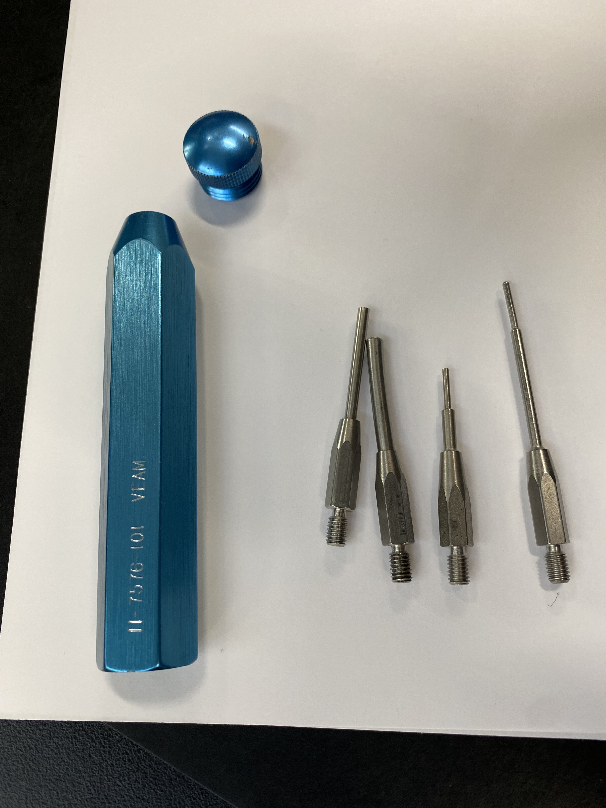

1. Veam a43240-8
   1. Unknown purchase source

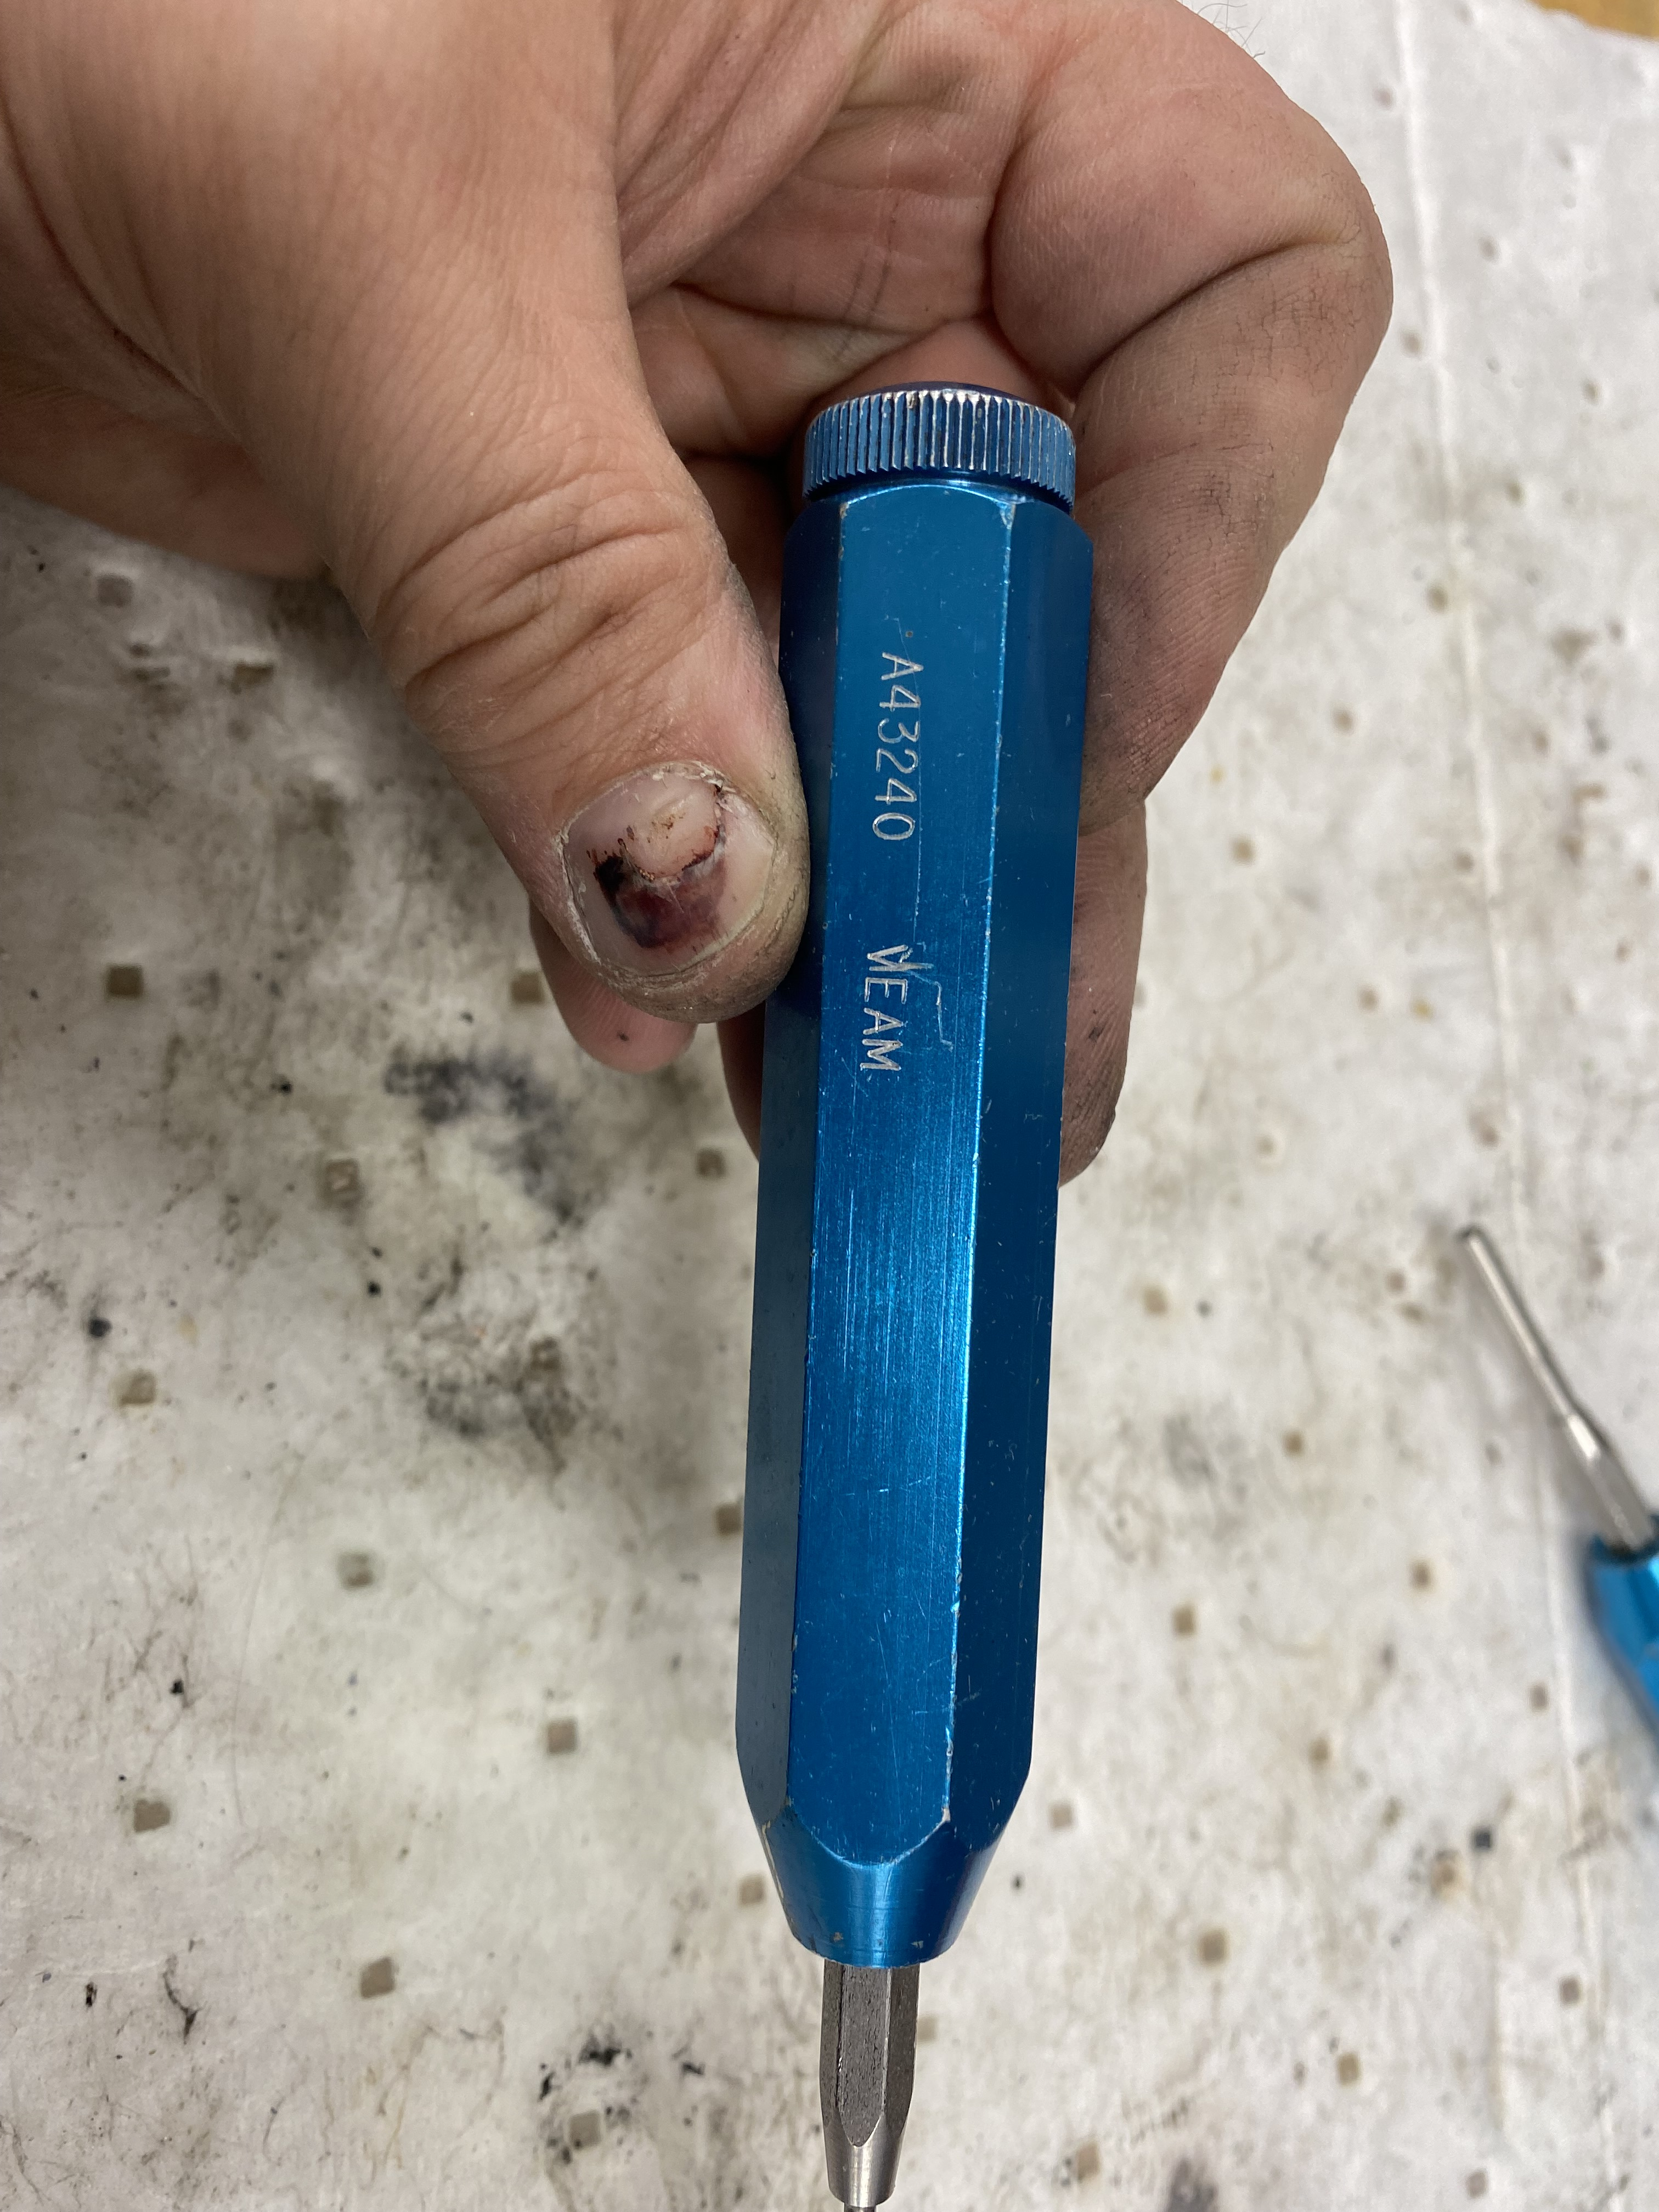

1. DMC pin tool pin 16 -$129
   1. https://dmctools.com/drk82
   2. 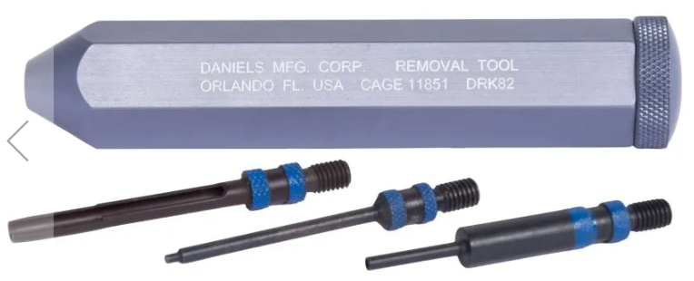
2. DMC pin tool pin 12 - $129
   1. https://dmctools.com/drk80
   2. 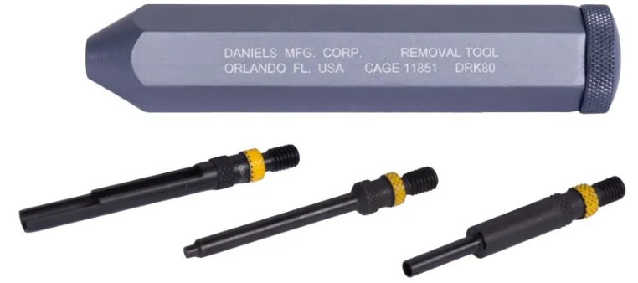
3. DMC pin tool Drk96 – $108.24
   1. <https://dmctools.com/drk96>
   2. 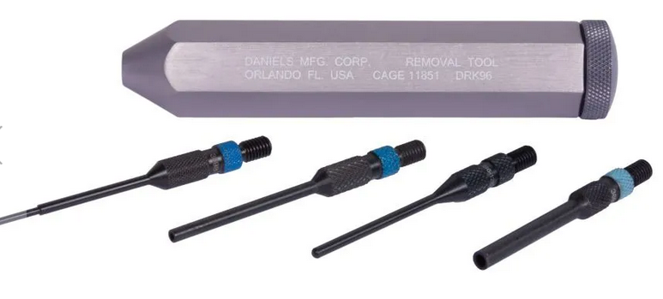
4. Jonard tools Ka260 $175.00 insertion tools
   1. https://www.digikey.com/en/products/detail/jonard-tools/KA-260/610384
   2. 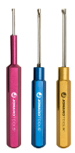
5. Jonard KR260 $175.00 extraction
   1. https://www.digikey.com/en/products/detail/jonard-tools/KR-260/610385
   2. 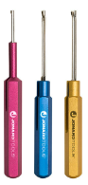

### Fine tip contact tools

1. TE 91067-2 $18.51
   1. https://www.digikey.com/en/products/detail/te-connectivity-aerospace-defense-and-marine/91067-2/15557
   2. 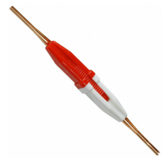
2. TE connectivity 91066-4 $20.71
   1. https://www.digikey.com/en/products/detail/te-connectivity-aerospace-defense-and-marine/91066-4/298281
   2. 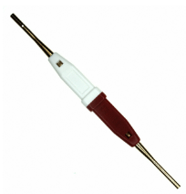
3. TE 91066-3 $20.91
   1. https://www.digikey.com/en/products/detail/te-connectivity-aerospace-defense-and-marine/91066-3/298280
   2. 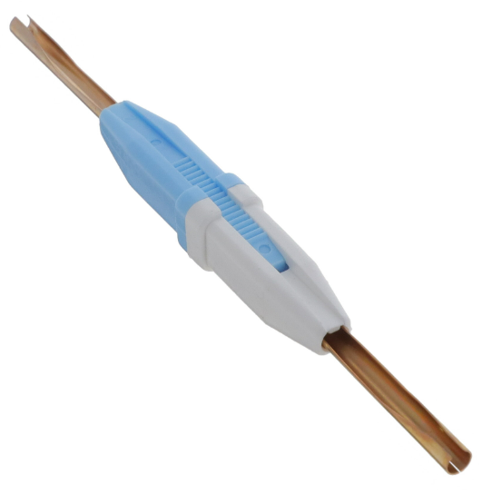
4. TE 91067-1 $18.20
   1. https://www.digikey.com/en/products/detail/te-connectivity-aerospace-defense-and-marine/91067-1/207259
   2. 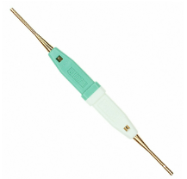
5. TE connectivity 1643915-1 plastic body $5.23
   1. https://www.digikey.com/en/products/detail/te-connectivity-amp-connectors/1643915-1/1636374
   2. 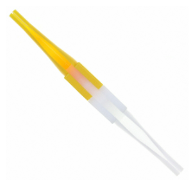
6. Astro tool corp M81969/14-03 pin size 16 $2.65
   1. https://www.digikey.com/en/products/detail/astro-tool-corp/M81969-14-03/4951912
   2. 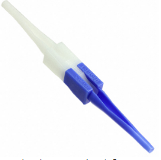
7. Astro tool corp M81969/14-04 $2.65
   1. https://www.digikey.com/en/products/detail/astro-tool-corp/M81969-14-04/4951913
   2. 

### Harting plugs

1. Han D plug Pin puller tool 09990000328 **$112.00**
   1. https://www.digikey.com/en/products/detail/harting/09990000328/3181503
   2. 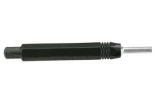
2. Pin puller tool HAN E 09 99000 0319 **$40.00**
   1. https://www.digikey.com/en/products/detail/harting/09990000319/3181502
   2. 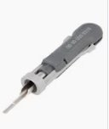
3. 09 99 000 0305 **$20.00**
   1. https://www.digikey.com/en/products/detail/harting/09990000305/3181498
   2. 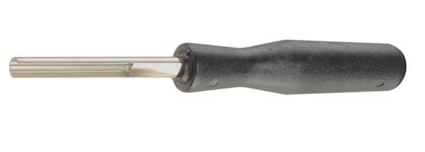
4. 0999 000 0315 **$75.00**
   1. https://www.digikey.com/en/products/detail/harting/09990000315/8035417
   2. 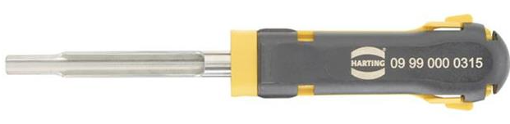
5. 09 99 00 0052 **$15.04**
   1. https://www.digikey.com/en/products/detail/harting/09990000052/3181484
   2. 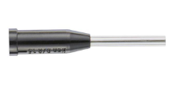
6. HAN d removal tool? 09990000012 **$63.04**
7. https://www.digikey.com/en/products/detail/harting/09990000012/3181482
   1. 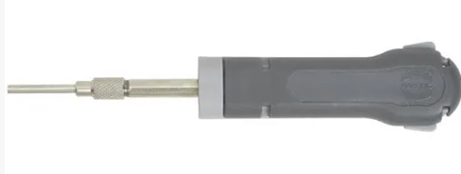
8. socket puller 09 99 000 0828 $179.00
   1. https://www.digikey.com/en/products/detail/harting/09990000828/5805900
   2. 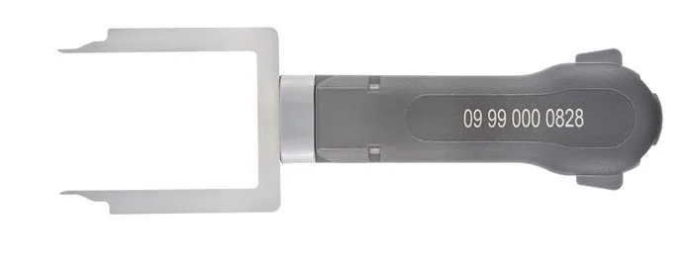
9. Sub D HAN contact removal tool 09990000368 **$28.25**
   1. https://www.digikey.com/en/products/detail/harting/09990000368/3181508
   2. 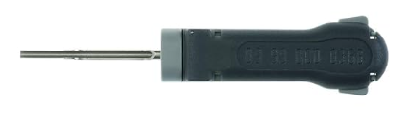

## Molex plugs

1. Mini fit jr pin remover 11-03-0044 **$28.54**
   1. https://www.digikey.com/en/products/detail/molex/0011030044/210947
   2. 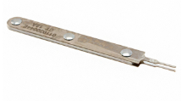
2. Mini fit JRready tool **$25.00**
   1. https:\www.jrdtools.com\products\jrready-dap-d173-mini-fit-jr-extraction-tool-molex-11-03-0044-for-mini-fit-jr-tm-series-terminals-30490-44476-44478-5556t-t2-t3-and-5558t
   2. 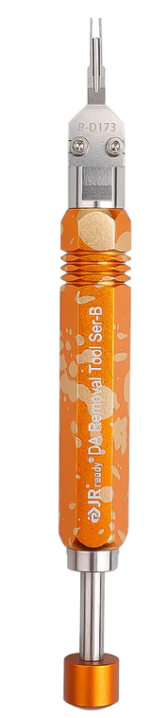
3. 0.084 Terminal Molex 0011010168 **$44.43**
   1. https://www.digikey.com/en/products/detail/molex/0011010168/63617
   2. 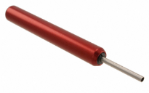
4. 0.093 Terminal Molex 0011030006 **$28.54**
   1. https://www.digikey.com/en/products/detail/molex/0011030006/228692
   2. 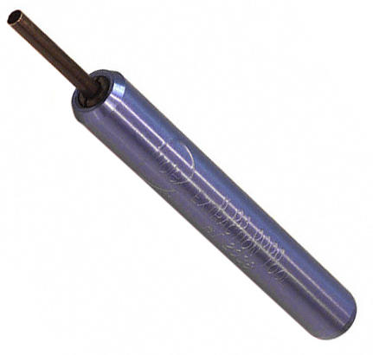
5. 0.062 Terminal Molex **$24.96**
   1. https:\www.digikey.com\en\products\detail\molex\0011030002\228689
   2. 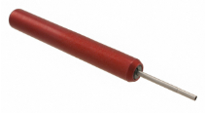
6. TE Connectivity/AMP D-sub? Tri-Met has previously had this tool.
   1. TE-91285-1 $ 40.00
   2. https://www.digikey.com/en/products/detail/te-application-tooling/91285-1/132443
      1. 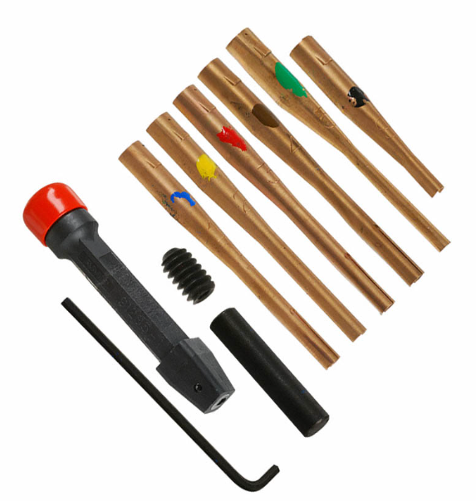

### TE Connectivity Mate-N-Lok

1. 465644-1 **$42.00 Tri-Met has had**
   1. https://www.te.com/usa-en/product-465644-1.html
   2. https://www.digikey.com/en/products/detail/te-application-tooling/465644-1/15682
   3. 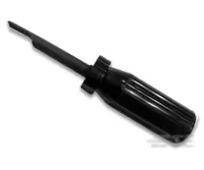
2. 465644-1 **$39.00 Tri-Met has had**
   1. https://www.digikey.com/en/products/detail/te-application-tooling/465644-1/15682
   2. 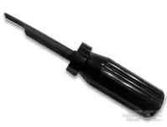
3. 1-305183-1 **$279.00 Tri-Met has had**
   1. https://www.digikey.com/en/products/detail/te-application-tooling/1-305183-1/1990885
   2. 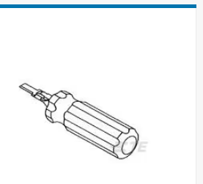
4. TE connectivity Mate-N-Lok extract 1-305183-1 **$279.00 Tri-Met has had**
   1. https://www.digikey.com/en/products/detail/te-application-tooling/1-305183-1/1990885
   2. 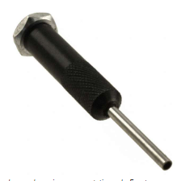
5. TE Connectivity Mate-N-Lok socket extract **189727-1 $33.00**
   1. https://www.te.com/usa-en/product-189727-1.html
   2. https://www.digikey.com/en/products/detail/te-application-tooling/189727-1/298755
   3. 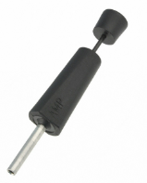
6. Universal Mate-N-Lok tool **9-1579007-5 $79.00**
   1. https://www.digikey.com/en/products/detail/te-application-tooling/9-1579007-5/4969883
   2. 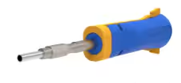

### TE Connectivity/AMP CPC (circular plastic connector)

1. removal tools TE-305183 **$17.46 trimet has had**
   1. https://www.digikey.com/en/products/detail/te-application-tooling/305183/15640
      1. 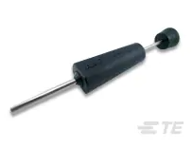
2. Removal tool TE 2063388-1 **$19.00**
   1. https://www.te.com/usa-en/product-2063388-1.html
   2. https://www.digikey.com/en/products/detail/te-application-tooling/2063388-1/2363487
      1. 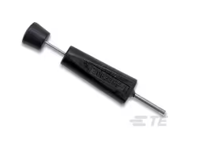
3. Insertion extraction 91285-1 **$40.00** Tri-Met has had
   1. https://www.te.com/usa-en/product-91285-1.html **$39.00**
   2. https://www.digikey.com/en/products/detail/te-application-tooling/91285-1/132443 **$33.00**
      1. 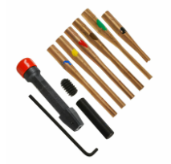
4. TE connectivity 9-1579007-1 **$65.00**
   1. https://www.digikey.com/en/products/detail/te-application-tooling/9-1579007-1/2053544
   2. 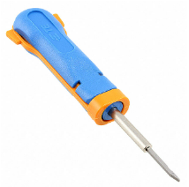

## Plastic contact tools

These tools are speculative right now as I think they will help with cannon plugs. They have not been tested.

1. TE Connectivity 114010 **~$2.00**
   1. https://www.digikey.com/en/products/detail/te-application-tooling/114010-ZZ/6566678
   2. 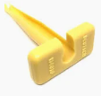
2. TE Connectivity 0411-337-1205 **~$2.00** EA
   1. https://www.digikey.com/en/products/detail/te-application-tooling/0411-337-1205/9477715
   2. 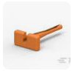
3. TE Connectivity 0411-204-1605 **~$2.00** EA
   1. https:\www.digikey.com\en\products\detail\te-application-tooling\0411-204-1605\6566672
   2. 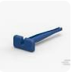
4. TE Connectivity 0411-291-1405 **~$2.00** EA
   1. https:\www.digikey.com\en\products\detail\te-application-tooling\0411-291-1405\6566674
   2. 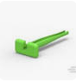
5. TE Connectivity 0411-310-1605 **~$2.00** EA
   1. https://www.digikey.com/en/products/detail/te-application-tooling/0411-310-1605/9477714
   2. 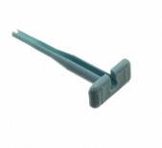
6. TE Connectivity 0411-336-1605 **~$2.00** EA
   1. https://www.digikey.com/en/products/detail/te-application-tooling/0411-336-1605/6566673
   2. 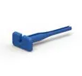
7. TE Connectivity 0411-240-2005 **~$2.00** EA
8. https:\www.digikey.com\en\products\detail\te-application-tooling\0411-240-2005\6566676
   1. 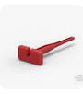
9. TE Connectivity 0411-354-1605 **~$3.50** EA
   1. https://www.digikey.com/en/products/detail/te-application-tooling/0411-354-1605/9477716
   2. 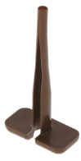
10. Amphenol sine AT11-337-1205 **$1.44** EA
    1. https://www.digikey.com/en/products/detail/amphenol-sine-systems-corp/AT11-337-1205/14011232
    2. 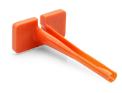

### Pin install pliers

1. Veam install plyers **$100.00** 11-7345 size 16 pin – Tri-Met has had a set or two on site
   1. https://www.mouser.com/ProductDetail/ITT-Cannon/11-7345
   2. 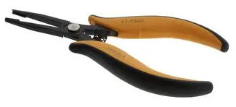
2. Veam install pliers p46736 size 12 pin – Tri-Met has had a set or two on site
   1. https://www.newark.com/veam/46736/insertion-tool-size-12-contact/dp/51M8181 **$245**
   2. 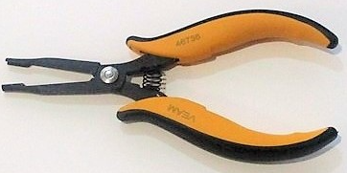
3. DMC install pliers DAK-168-16 pin size 16
   1. https://dmctools.com/dak489 **340.13**
   2. 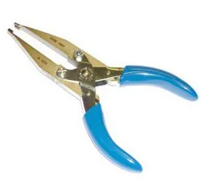
4. DMC install pliers DAK168-12 pin size 12
   1. https://dmctools.com/dak168-12 **$332.34**
   2. 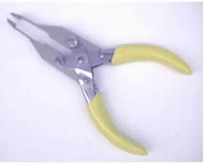
5. TE connectivity 91002-1 **$54.86 Tri-Met has had**  
   TOOL INSERTION .062 & .093 CONN
   1. https://www.digikey.com/en/products/detail/te-connectivity-amp-connectors/91002-1/29746
   2. 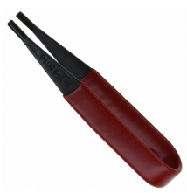

## The great unknown – why we need generic pin tools.

JR-ready kits for unknown and unexpected situations.

These items can be found on the company’s web site. https://www.jrdtools.com/

1. JRready st5211 **$22.00**
   1. 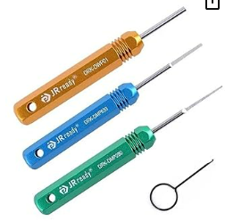
2. JRready st5252 **$40.00**
   1. 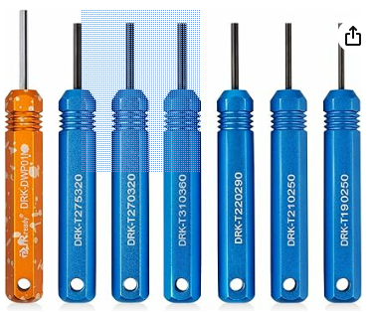
3. JRready st5236 **$50.00**
   1. 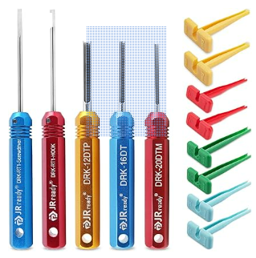
4. JRready st5227 **$50.00**
   1. 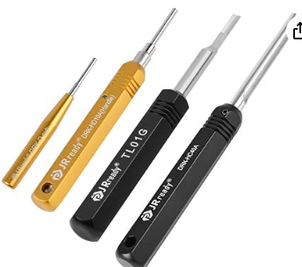

### Wire stripping tools

1. Ideal brand stripmaster **$40-120**
   1. Goto the manufacturer site listed below to find which model you want!
   2. 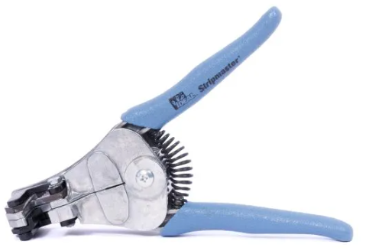
   3. https://www.idealind.com/us/en/shop/product-type/aerospace/stripmasterr.html
   4. 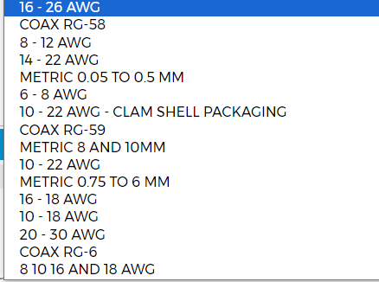
2. Various gauged strippers
   1. Snap on PWCS7ACF **$60.00**
      1. 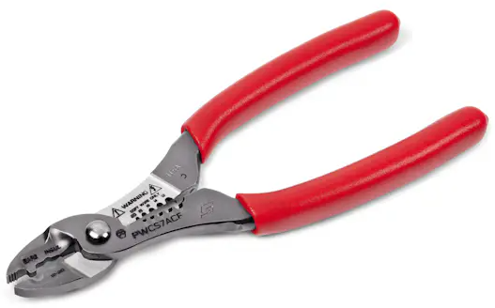
   2. Snap on 9 inch stripper pwcs9acf **$67.00**
      1. 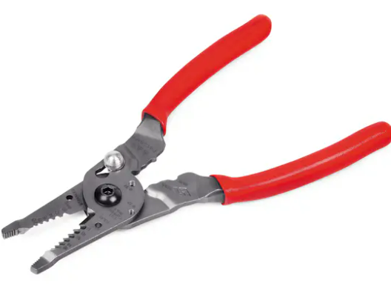
   3. Engineer wire stripper
      1. https://www.engineertools-jp.com/pa05060714
      2. 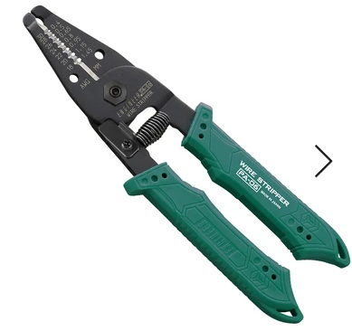
3. Coax stripping tools
   1. Ideal 2 blade adjustable 45-526 1/4 in. strip between blades
      1. https://www.idealind.com/us/en/shop/45-526.html
      2. 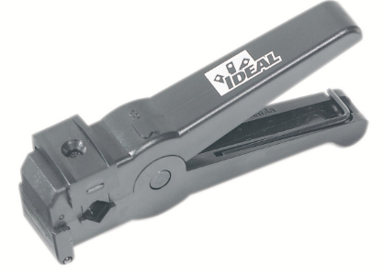
   2. Ideal3 blade adjustable 45-520
      1. https://www.grainger.com/product/5LJ22
      2. 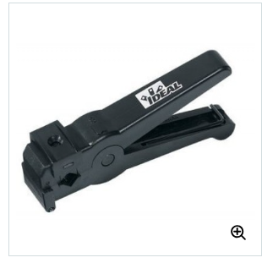
   3. Ideal 45-605
      1. https://www.grainger.com/product/IDEAL-Coax-Cable-Stripper-1-4-in-46AN71
      2. 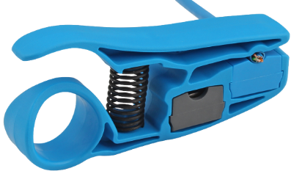
   4. Ideal 45-165
      1. https://www.grainger.com/product/5LJ07
      2. .240”/6.1mm blade spacing, strips from  from .187”/4.8mm up to .313”/8mm in diameter
      3. 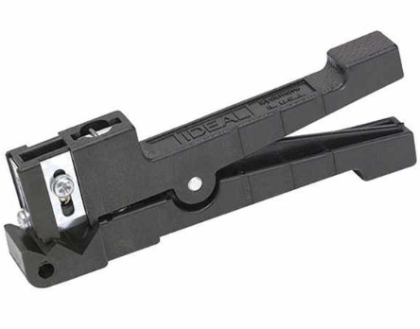
   5. Ideal 45-162
      1. https://www.grainger.com/product/5LJ04
      2. 240”/6.1mm blade spacing, Strips up to .125”/3.2mm in diameter
      3. 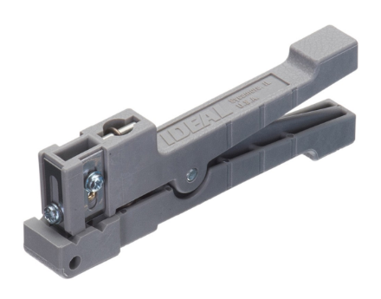
   6. Ideal 45-164
      1. https://www.grainger.com/product/25D026
      2. .560”/14.22mm blade spacing, Strips from .250”/6.4mm up to .563”/14.3mm in diameter
      3. 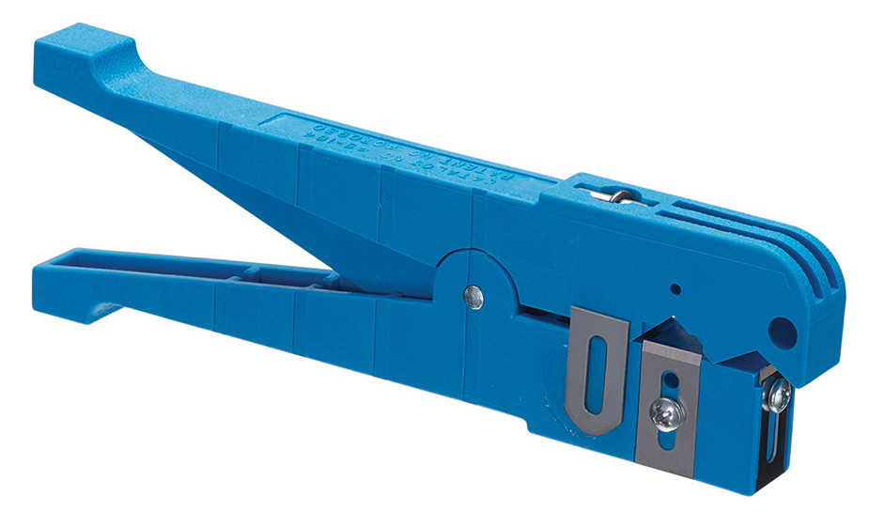
   7. Ideal 45-163
      1. https://www.grainger.com/product/5LJ05
      2. .240”/6.1mm blade spacing, Strips from .125”/3.2mm up to .250”/6.4mm in diameter
      3. 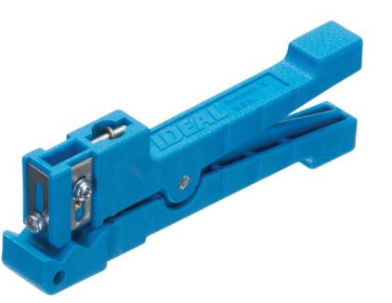

# Bonus round!!!

### Cannon plug pliers.

1. Snap-on AT1508KG **$45.05**
   1. **Tri-Met has had**
   2. 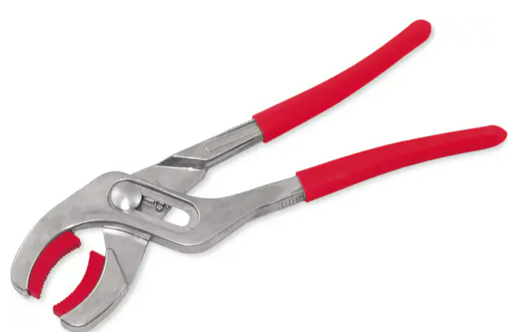
2. Snap-on pwc53 **$93.00**
   1. 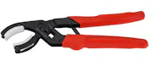
3. Snap-on pwc5330 **$93.00**
   1. 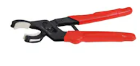
4. Blue point PWC52A **$66.00**
   1. **Tri-Met has had**
   2. 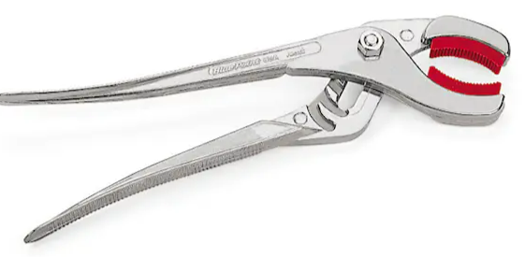
5. Daniels 30 degree head BT-SJ-509A **$87.00** – same as Snap-On?
   1. https://dmctools.com/bt-sj-509a
   2. 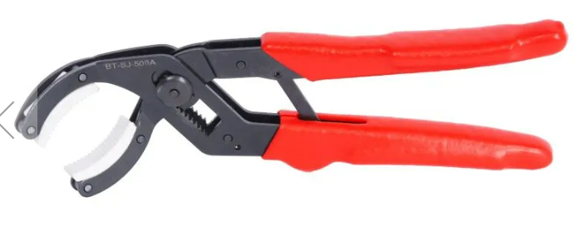
6. Daniels straight head BT-SJ-509R **$84.21** same as Snap-On?
   1. https://dmctools.com/mini-soft-jaw-pliers-straight-head
   2. 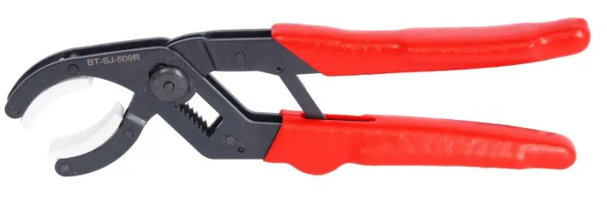
7. Knipex 81 11 250 **$44.00**
   1. **Tri-Met has had**
   2. 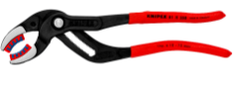
8. Knipex 81 01 250 **$35.35**
   1. **Tri-Met has had**
   2. 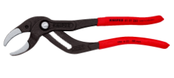
9. Stanley J253G **$33.86**
   1. Source from amazon. **Tri-Met has had**
   2. 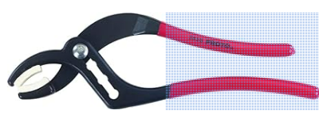
10. SK tools 7625 **$75.00** 
    1. Source from amazon. **Tri-Met has had**
    2. 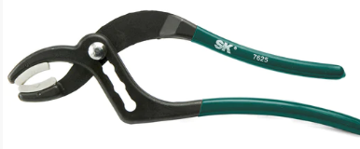

# Terminal activation tools

1. Pheonx contact 1200135 **$24.00**
   1. https://www.digikey.com/en/products/detail/phoenix-contact/1200135/6163337
   2. 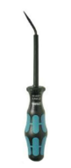
2. Wago 210-719 BLADE: 2.5 X 0.4 **$10.00**
   1. **Tri-Met has had**
   2. https://www.digikey.com/en/products/detail/wago-corporation/210-719/13549325
   3. 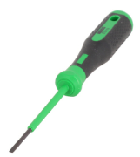
3. Wago 210-720 BLADE: 3.5 X 0.5 **$11.00**
   1. **Tri-Met has had**
   2. https://www.digikey.com/en/products/detail/wago-corporation/210-720/13549418
   3. 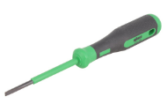
4. Wago 210-721 BLADE: 5.5 X 0.8 **$18.15**
   1. **Tri-Met has had**
   2. https://www.digikey.com/en/products/detail/wago-corporation/210-721/13549313
   3. 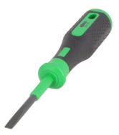
5. Wago 210-722 tool set **$36.47**
   1. **Tri-Met has had**
   2. https://www.digikey.com/en/products/detail/wago-corporation/210-722/13549336
   3. 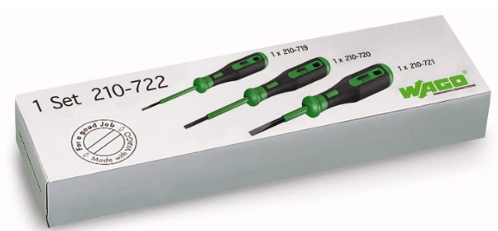
6. Wago 210-658 BLADE: 3.5 X 0.5 **$11.00**
   1. **Tri-Met has had**
   2. https://www.digikey.com/en/products/detail/wago-corporation/210-658/13549492
   3. 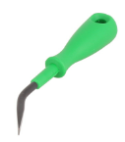
7. Wago 210-648  BLADE: 2.5 X 0.4 **$11.00**
   1. **Tri-Met has had**
   2. https://www.digikey.com/en/products/detail/wago-corporation/210-648/13549391
   3. 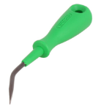
8. Wago 210-657 BLADE: 3.5 X 0.5 **$10.00**
   1. **Tri-Met has had**
   2. https://www.digikey.com/en/products/detail/wago-corporation/210-657/13549332
   3. 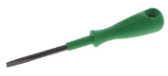

# Tool kits

Veam manufacturer tool kit. This is what I recommend for the cannon plug ecosystem.

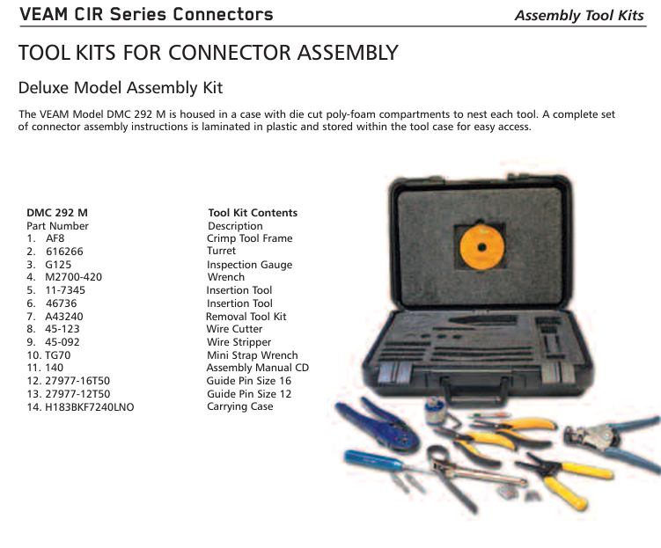

<https://dmctools.com/products/tool-kits>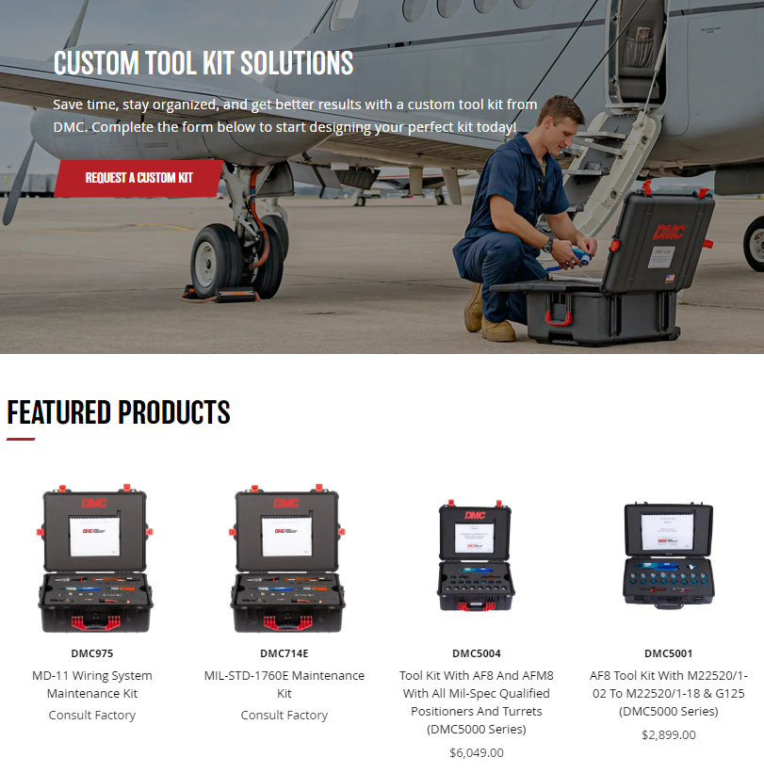

Maybe we should contact Daniels to assemble a generic tool kit?

Pulled from “Commercial Hand Crimping Tools” catalog from this site page

<https://www.te.com/usa-en/products/application-tooling/hand-crimping-tools.html>

I like the tool box shown here

